Analysis Methods

The question at hand

Does nectar volume change significantly in arrowleaf balsamroot plants from control plots to heated plots?

* Two years: 2015 and 2016
* 6 control and 6 heated plots
* Multiple plants within each plot (different number for each plot)

Analysis methods

I started by doing some data exploration. A histogram for the data:

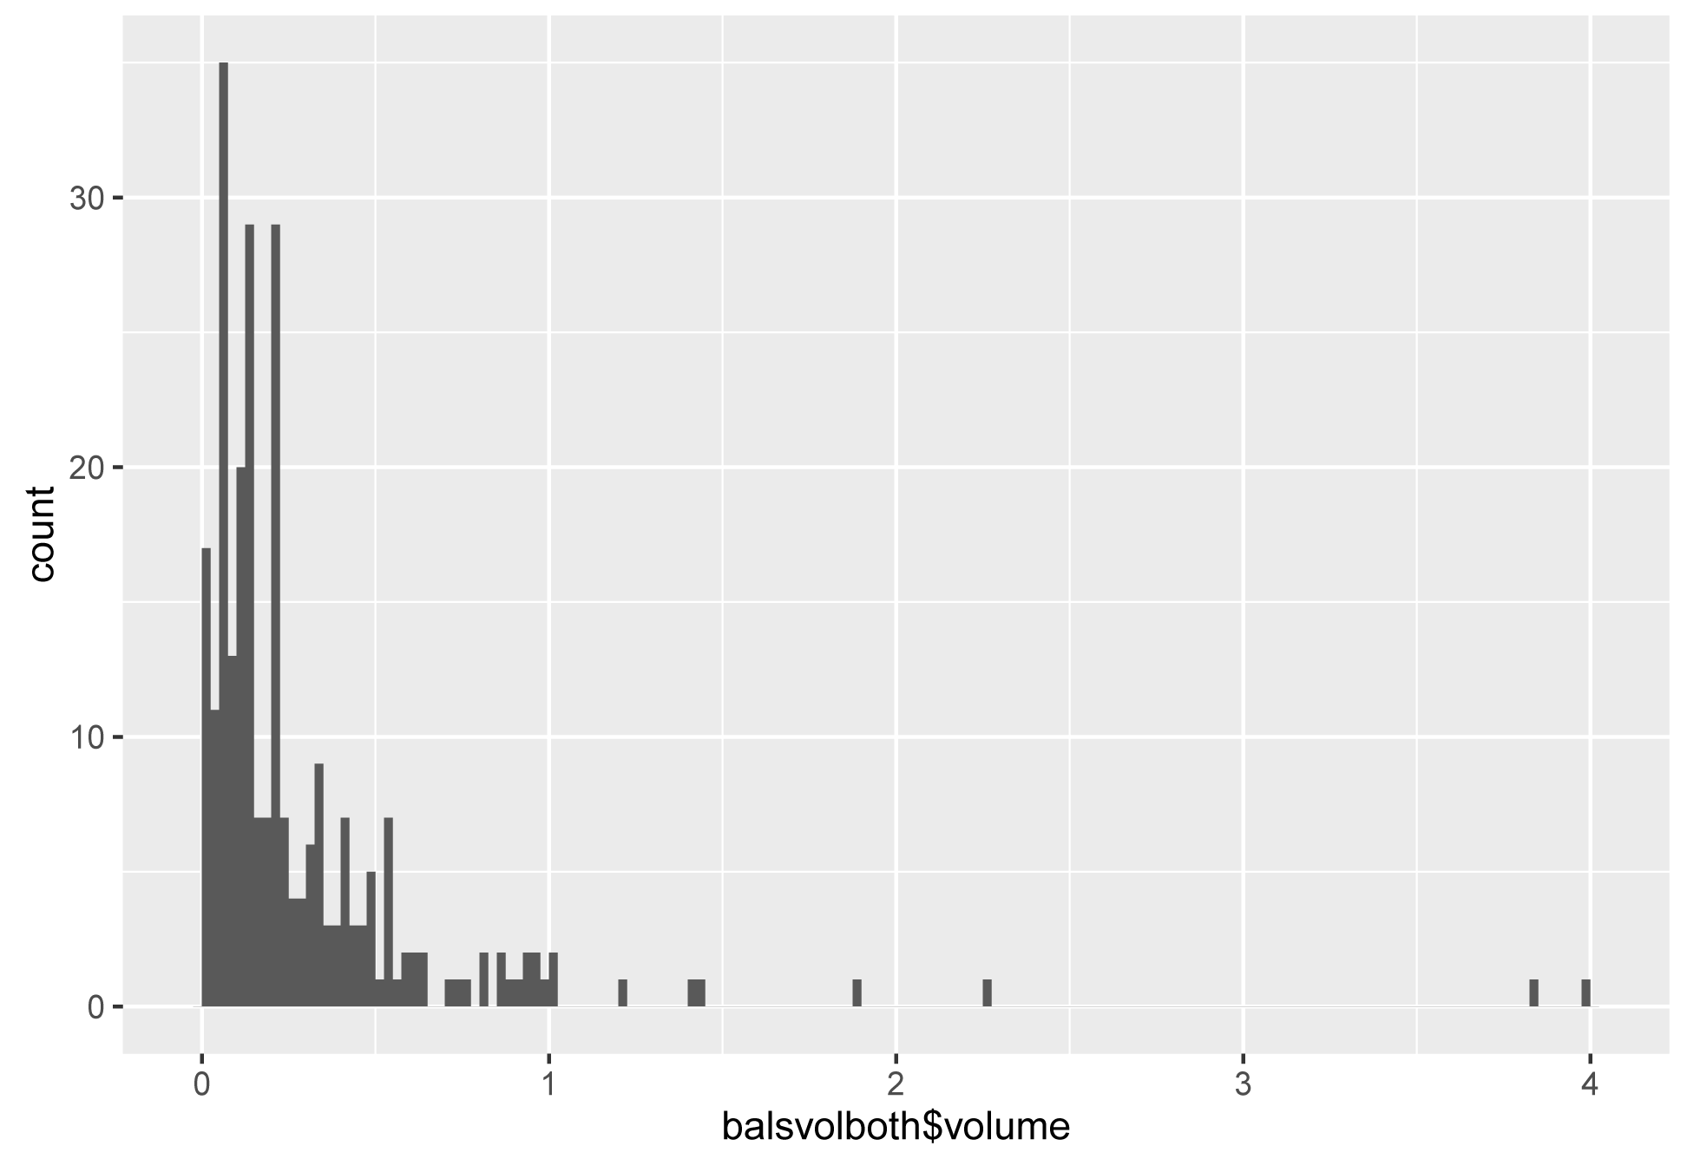

Outliers

Sample size

Control: 116

Heat: 144

Data summary

All volumes expressed in μL

Min: 0.01818

Overall median: 0.1664

Overall mean: 0.29413

Max: 3.9818

Mean C: 0.29279

Mean H: 0.29520

Variance ratio (H/C): 1.2363

Not worried about normality because the samples sizes are large. Homoscedasticity looks okay with a variance ratio of 1.24. The two outliers are potentially worrisome.

The model:

lmer(volume ~ treatment \* year + (1|plot/plant))

Nested random effects: plant within plot

Year is conceptually a random effect but I only have two years of data so I modeled it as a main effect.

Diagnostics

The residual plot shows increasing lack of fit at higher values:

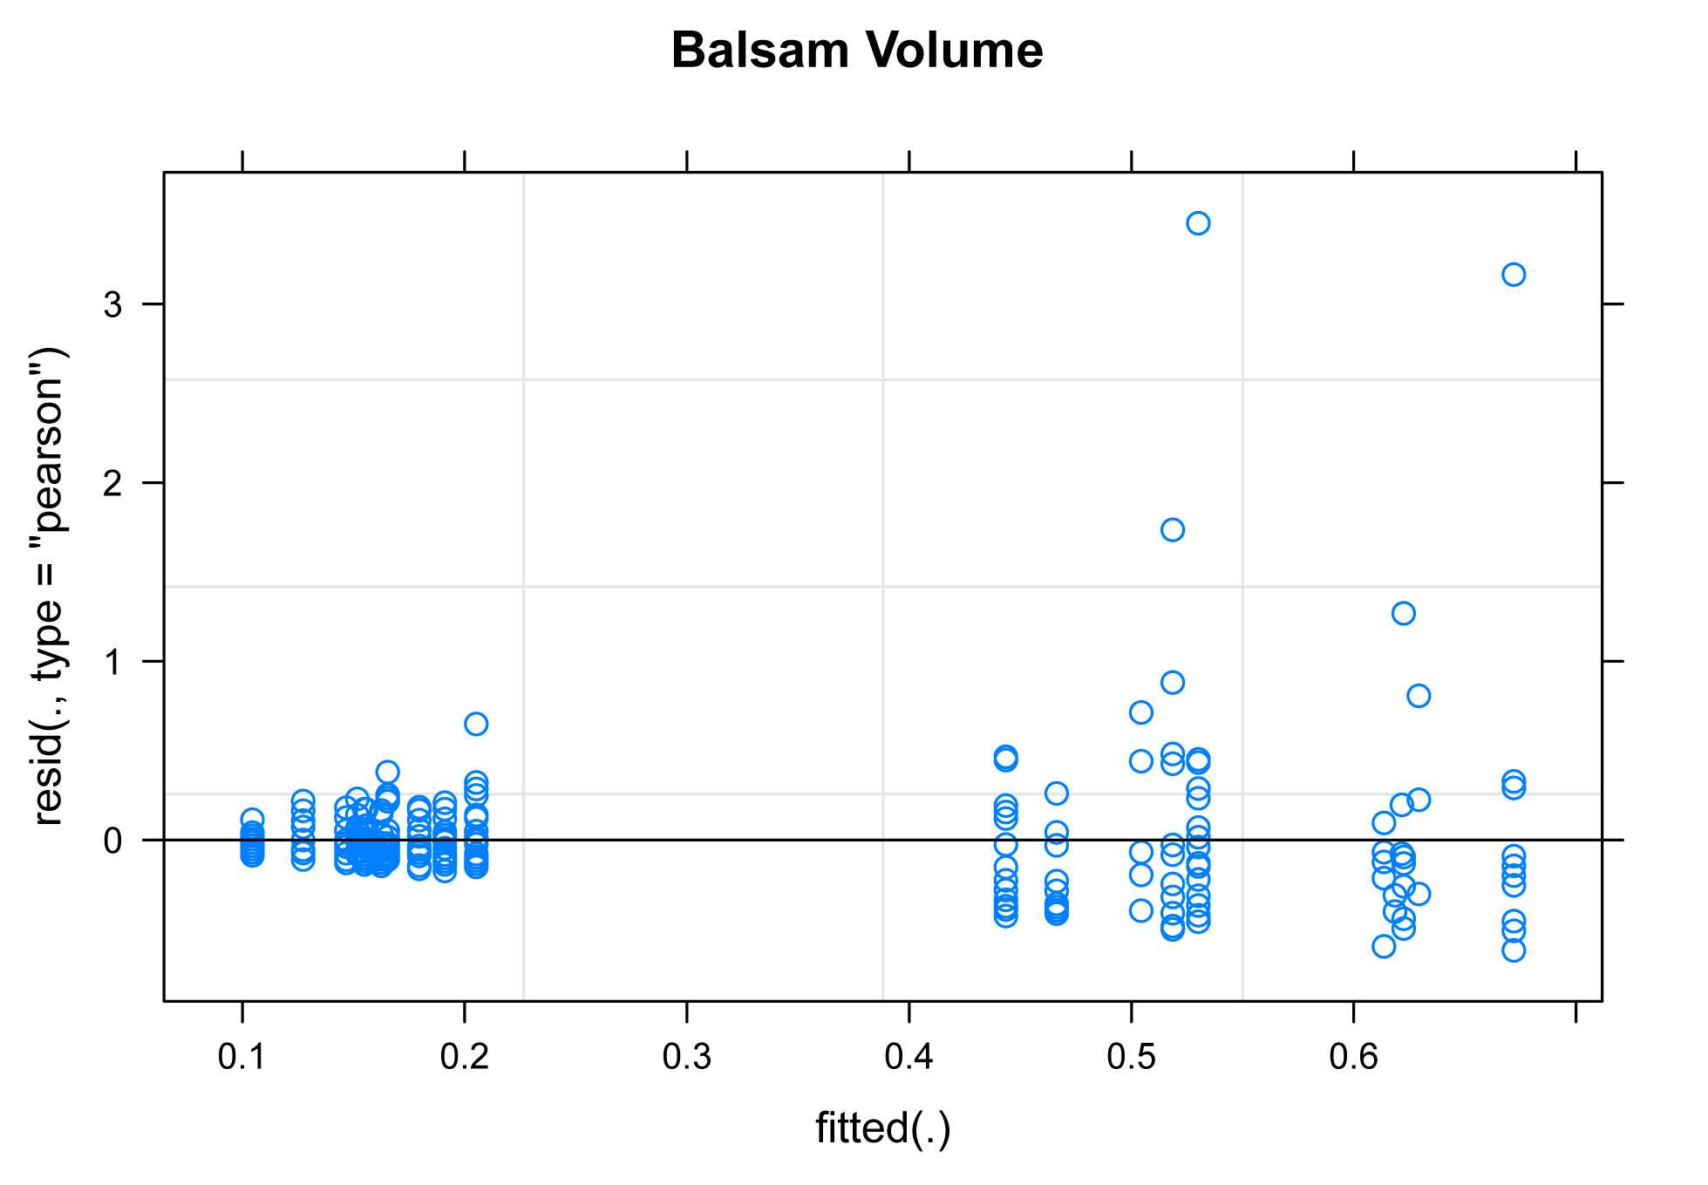

Outliers

Cook’s distance indicates that the two outliers together could have a disproportionate influence on the model (Cook values .36 and .40 respectively, rule-of-thumb threshold is 1.0). Removing these outliers could be justified biologically because notes on the data sheet indicate that the morning was on the wet end of our protocol, so dew might have skewed the results. I ran the analysis after removing the outliers, and the results were effectively the same, so I kept the outliers in when I calculated results.

Contrasts and ANOVA results

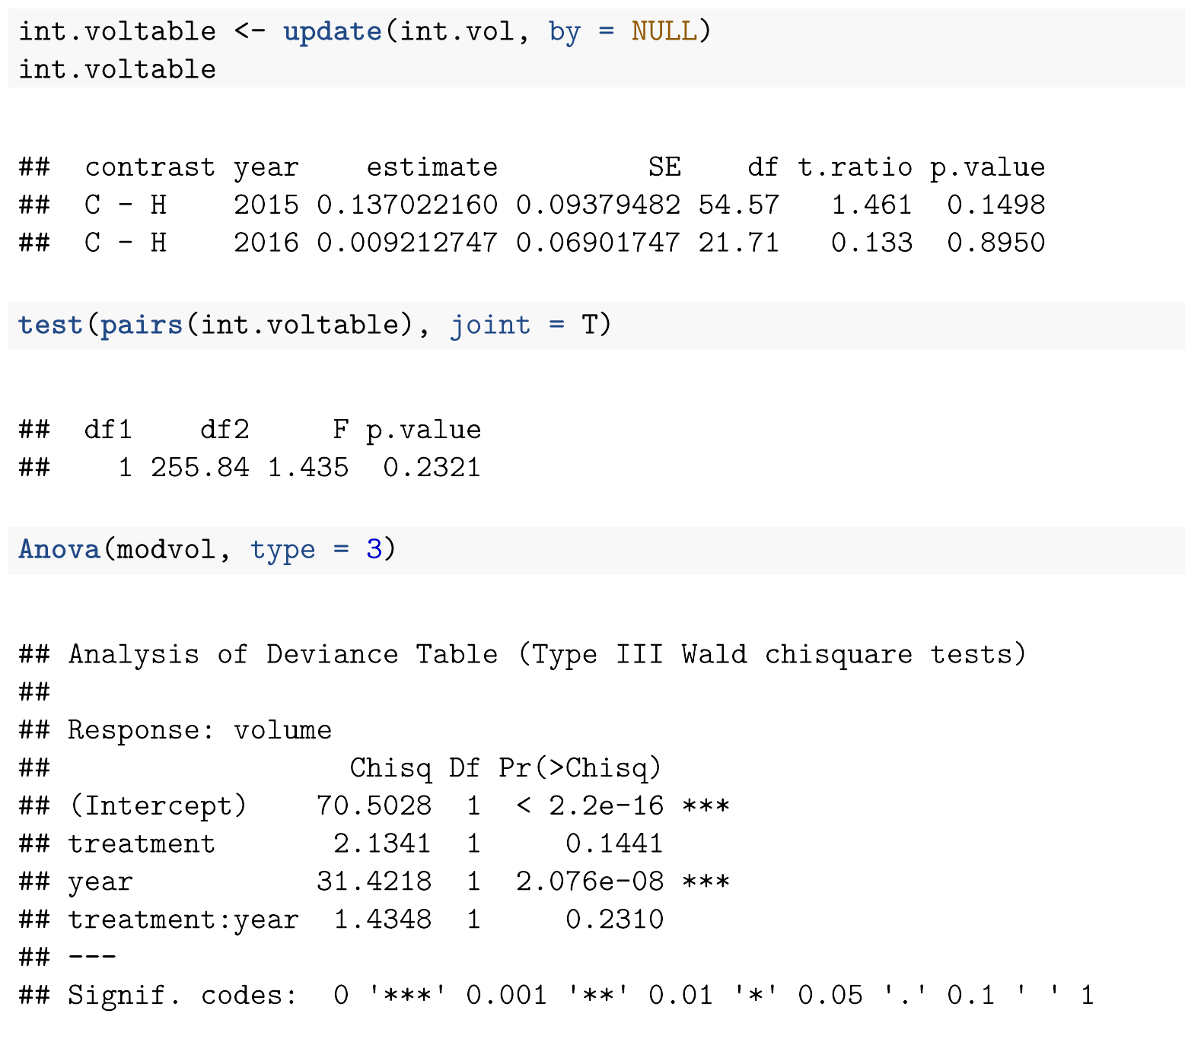



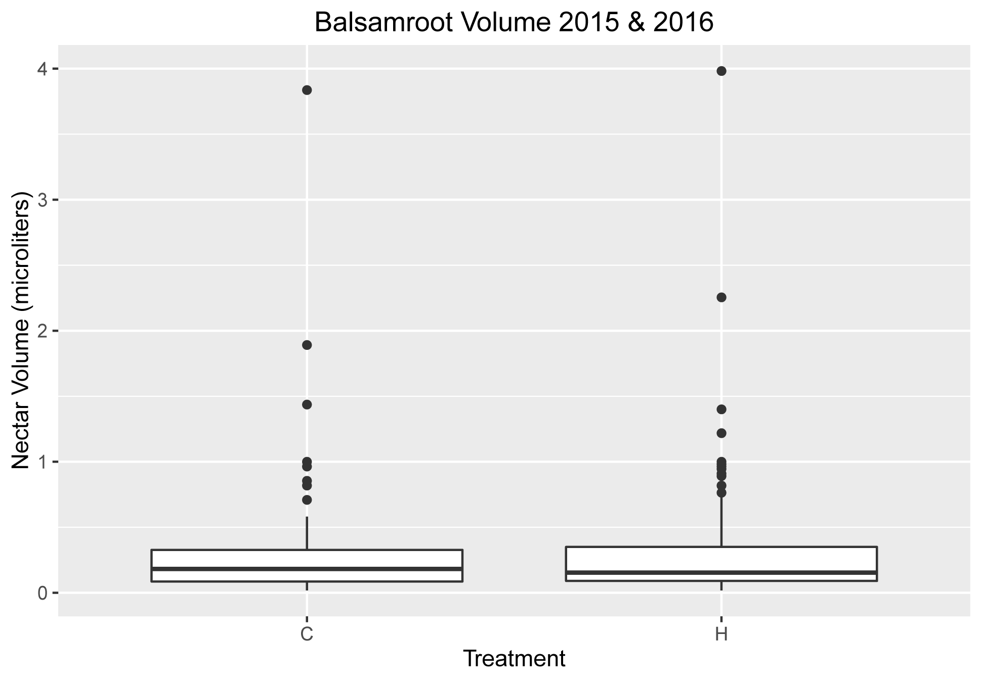

Outliers

No significant different in nectar volume between heated and control plots for arrowleaf balsamroot.